Homework 1 – Smart Parking Platform
By: Riyan Momin
1: Analysis:
There are some parking apps and websites already, that can show you where open parking is, pay for the parking, and reserve specific parking spots also. There are 4 examples which I looked into, which are ParkMobile, Spothero, PaybyPhone, and Passport parking. Every app has its own advantages, and dis-advantages as well.
ParkMobile is good to find and reserve open parking spots and pay for it through your phone also. It would show you open parking spots and you can reserve that spot directly from your phone, which is very convenient.
Spothero: For events and airport parking, you can reserve it in advance, and pay for it for how ever long you want the parking spot for. This app also makes it easy to reserve the parking location directly through your phone. Although, this app doesn’t completely show which parking spots are filled or not, so you kind of have to take time to search for open ones and correct one where your car can fit.
PaybyPhone: This app is convenient for parking alerts, if anything is going on and you’ve parked there and put it in the system, you would receive notifications regarding any alerts or dangers or anything. This app isn’t the best for cities which don’t have a lot of parking options since it might be out-dated.
Passport parking: This app is very good for simple users, since the payment is easy to do, and you also get parking information and alerts.
2: Draft of Vision and Scope:
For this semester project, we are the company $oftware corp, which has unlimited resources and a unlimited budget. This company has been chosen to manage and plan the development of a smart parking platform, which includes a website and mobile apps also. The main goal is to create an app and website where drivers can easily find, pay for, and reserve parking spots.
The vision is to make parking easier for drivers, and also for the parking lot management for better options on how to manage their parking lot easier. There should be like an admin side, which would be for the parking lot management, and then a user side, which the drivers would use to find parking easily.

The system would have the following features.:
Website and Mobile app
Admin login per parking lot management
Admin dashboard of what cars are parked where and for how long
User signup
Real time update for the parking lot
Up-to-date parking lot map
Digital payment from phone app or website
Reservation for parking
Parking lot measurement if a truck or big car can fit or not
Receipts sent to phone number or email
History of where you have parked before
Important alerts and notifications
End of the day, week and month analytics for admin and both user
Stakeholders:
Drivers and car owners
Parking lot management and owners
System admins
Website and mobile app users
Payment providers
Billing side
Website and app development team

3: SRS Draft 15 use cases:
The following use cases is the first draft, which show how the app and website will work for both the user, and admins, and how they can use it easily and save time also.
1: The driver/user creates an account and enters their required account information, like name, email and phone number.
2: The driver/user logs in and the online system verifies that everything is updated and stored in the database.
3: The driver/user can search for parking and the system will start searching.
4: The system will then show the driver/user which spaces are open.
5: The app/website will show the exact parking spots open in the map
6: If the driver/user clicks on exact parking spot then it will show the driver/user the information about the parking spot, like the number, and pricing.
7: The driver/user can then reserve a parking spot and choose for how long they want to reserve it, and wait for the payment screen.
8: This is where the payment provider will come in. The driver/user will have to pay for their selected spot, and wait a few seconds to make sure it’s confirmed and paid for.
9: When confirmed, the driver/user will be shown the directions to their exact parking spot.
10: The driver/user will receive information alerts and notification about the drivers specific parking spot, and the parking lot also for safety.
11: The driver/user can view their receipt which would be saved on the app, as well as either sent to their phone number or email, this depends on what option the user chooses.
12: The driver/user can then view their account history, where they have parked, for how long, and how much they paid also.
13: The parking management will log into their admin side user to view information.
14: The admin side will show how many parking spots are open and how many are filled.
15: The parking lot management will see the parking data, how many cars have been in and out of the parking lot, for how long a specific car was parked at a specific spot, and the option for rates also.

4: The differences between other apps and ours
The main difference between the other apps and ours would be that everything is on one platform, making it easy for users and the admin also. The driver/user can search for parking, see which spots are open, reserve it for a specific time, and then pay for it and see the directions on their phone for the parking lot, and then get confirmation receipt also. The admin side for the parking lot management will have a dashboard showing how many spots are filled and how many are open, what cars have been in and out, and the rates also.
5: Conclusion
This first homework is just the start for the semester project. As stated from before, there are multiple apps for parking, so our apps needs to be much better and user friendly for people and companies to actually switch over to our app. Moving further down the road, updates will be made and more features would be coming out in the future.

Homework 2 – WBS and timeline for Smart Parking Platform
The work for this week is to break down the structure of the website and the application, so we can have the database good to go, and the key features pointed out and ready to develop. This week will improve the development and put the ideas into use and how they will actually be imbedded into the application from all the ideas and thoughts from week 1.
- Smart Parking Platform
  - Frontend Website
1.1.2 Main homepage and the map view
1.1.3 Parking reversation and payment
1.1.4 User account dashboard and other features
1.2 Mobile Applications
1.2.1 iOS Application
1.2.2 Android Application
1.2.3 Login access
1.2.4 Notifications and alerts
1.3 API services and backend
1.3.1 Secure registration
1.3.2 Secure Login
1.3.3 Separate users
1.3.4 Admins and regular users signup
1.4 Reservation and parking engines
1.4.1 Real time map
1.4.2 Updates of the parking spots in real time
1.4.3 Booking engine
1.4.4 Reservation engine
1.5 Payment Processing
1.5.1 Third party payment services
1.5.2 Build payment into application and website
1.5.3 Receipts
1.5.4 Billing history
1.6 Location Services
1.6.1 Interactive Map
1.6.2 Real time live map
1.6.3 Vehicle size and fitment per spot
1.6.4 Directions using map to the parking spot which is reserved by user
1.7 Admin Dashboard
1.7.1 End of the day/week/ and month reports and analytics
1.7.2 Pricing management
1.7.3 Add remove and edit admins and users
1.7.4 Add remove and edit parking spots
1.8 Testing
1.8.1 Integration testing
1.8.2 Users and admins stay separate testing
1.8.3 No bugs or glitches testing
1.8.4 Security testing for both users and admins
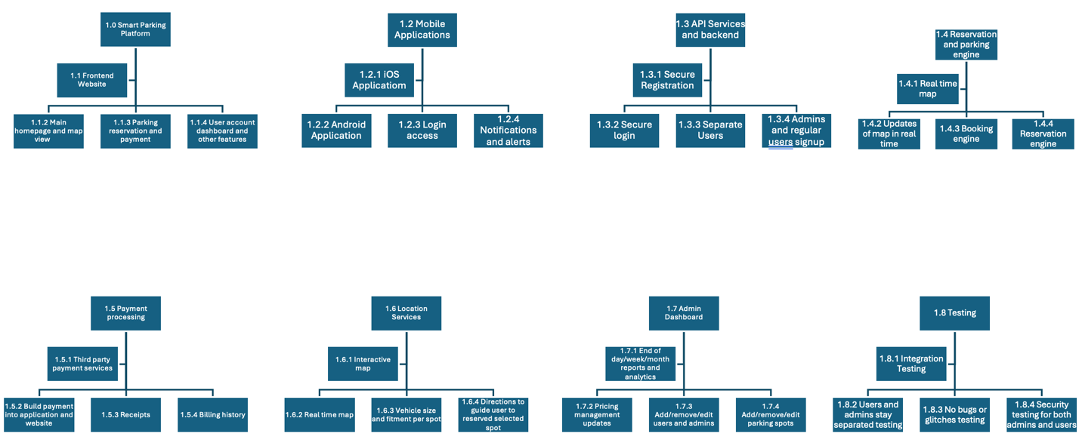
Grantt Chart
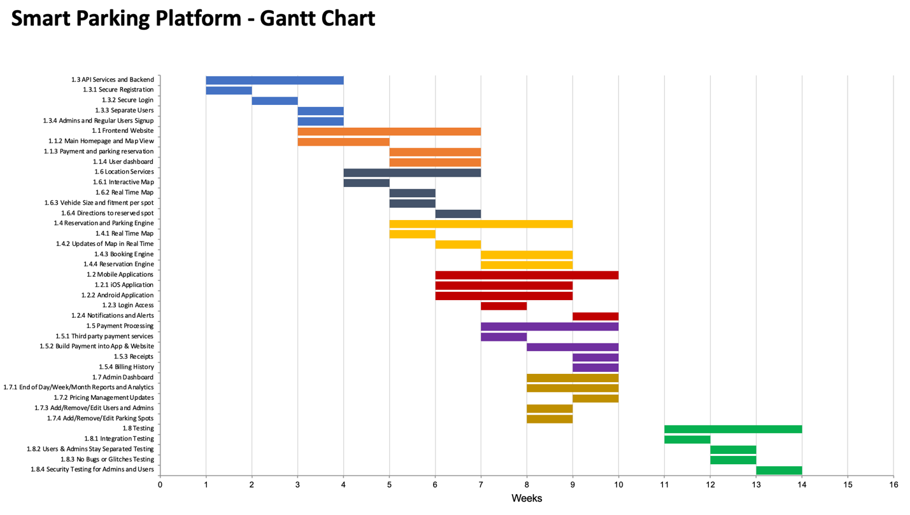

The main milestones for week 2 is that the main backend, website, application and mapping is integrated into a working draft.

Homework 3: Backlog and Sprint 1 Plan
The work for this week is to create a backlog system using Homework 1 features, and the breakdown structure from Homework 2. The 1st sprint creates accounts, separation between users and roles, the data, and splash screens, and then later on, additional features will be added.
Login 5 Items
- Create user/driver account with name, email, phone number and password
- Create admin account for the management of the parking management
- Sign in using the email and password
- Have a recovery password email sent through secure email
- Automatically sign out and expire the session due to inactivity

User and Operator interface
- User/driver screen with nearby parking and searching engine
- Search results show up that are nearby, if it’s available, and the pricing
- Real-time useable map with open parking spots shown
- Parking details with real-time rates per hour, and parking size limits also
- Space detail view
- Vehicle profile with car type, and license plate number
- Time selection and reversation details
- Confirmation screen and reservation timing
- Payment status and checkout screen
- Directions to parking garage, and selected reserved spot
- Driver homescreen dashboard and reserved spot
- Receipt viewer and reservation history
- User/driver notifications and alerts through app, text, and email
- Operator/admin dashboard with taken and open spots
- Operator/admin map with space status, and what cars are parked where with payment status and vehicle information
Backend process for User and Operator
- Store driver/user and operator/admin accounts securely and safely
- Have role permissions for user/driver and operator.admin
- Fix issues with revoked authenticated sessions
- Maintain management, spaces, spots, and pricing
- Have parking space occupancy updates every 15 minutes
- Publish real-time search and maps
- Filter spaces using the vehicle information which user/driver inputted
- Check avaible spots when reservation is requested
- Hold/lock a spot for 5-10 minutes while checking out
- Create and expire reservations during the selected times
- Automatically calculate the pricing rate depending on the duration of the stay
- Send payment request
- Create receipt and put it into the user/driver account history
- Send reservation confirmation and time alerts before expiration
- Record and keep the occupancy and pricing changes
Reporting for User and Operator
- User/driver report of parking session by selected date
- User/driver report of spending
- User/driver history of receipts and payments
- User/driver of commonly used parking garages
- User/driver report of overstayed and canceled reservations
- Operator/admin daily report of parking spots
- Operator/admin weekly occupancy trend
- Operator/admin monthly total overview reports
- Operator/admin revenue report by parking garage and selected dates
- Operator/admin of bookings, cancellations, parking rates, average duration, and total reports
Trello Board:
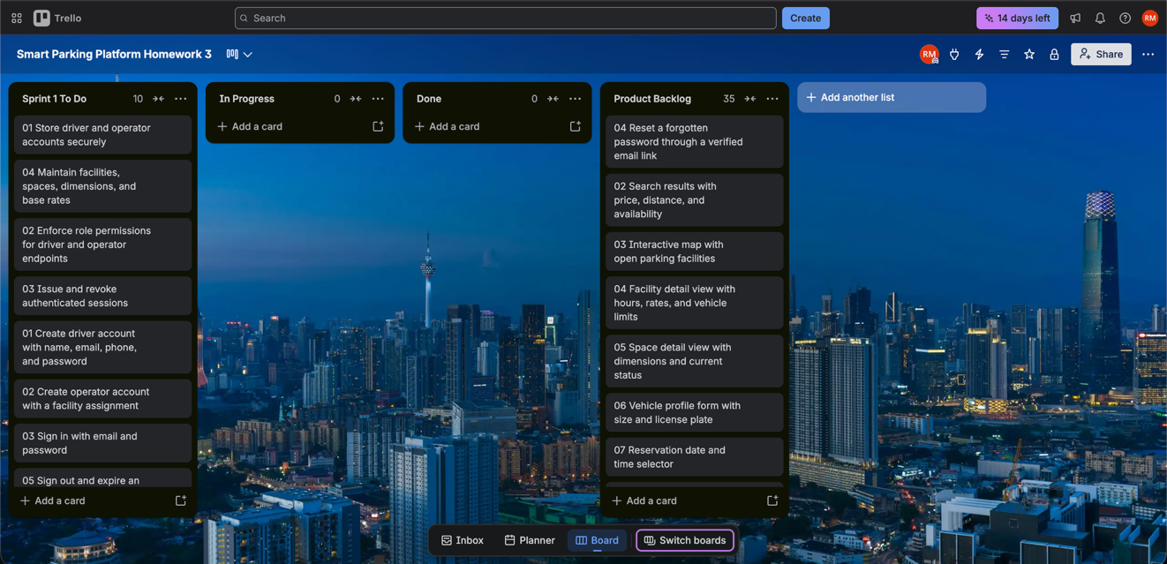
Homework 4: Risks and Communication Plan
For this week’s homework, I’m looking at things that can go wring while making the Smart Parking Platform, and how the teams can stay in touch and work together to fix these issues. The main purpose of the app is to let drivers find, reserve, and pay for the parking spot they selected, and for the admin, it’s to see the overview and management of their parking garage locations.
Technical Risks:
- Occupancy shows taken spots as open
The chance of this happening is high, and it’s very crucial to make sure it doesn’t happen. The fix would be to have a timestamp for each parking spot, and block booking for that when another user is selecting or paying for it.
- Requests for double booking the same spot
The chance is medium for this, and the backend would need to be fixed. Have a transaction ID lock and expiration which is secure
- Payment or live map has an outage
Outages aren’t super common, nor super rare, so this would be a medium chance. The user can retry to pay or refresh the map, and on the backend API, it automatically logs this issue and failure for the backend team to look into.
- Another user or admin data is exposed
This would be a low chance because everything would be super secure and isolated. If it happens, then we can check the role-based accesses and do more security tests.
Schedule Risks:
- Cross team running late
Chance of this is high, and to overcome it, it’s the project managers responsibility to set the contracts early and make sure everything is running smooth
- API setup approval is delayed
Chance of this is medium, and what we can do it request early access and develop drafts and track the approval timeline.
- Requirements change
Chance of this is high also, since features, and other things can be getting changed. What to do is that have a demo rate and reservation for it and record and ask in advance of what features need to be there
- Device and garage testing take longer
This is also a high chance of happening due to errors, or changes not being in effect. To overcome this we can reserve a time and test it before so whatever coverage fails, we can fix it fast.
Financial Risk:
- Payment fees exceed the cost
Chance of this is medium, and we need to monitor the costs every week, if not everyday. If it’s too high, then look into other companies for the transaction fees.
- Text, map, and cloud usage increases
The chance of this is high, and what we can do is set data limits and cost limits also, and monitor it to often.
- Incorrect charges cause refund work
Chance of this is medium, and what we can do is use idempotent charges, daily reconciliation, and have a refund workflow
- Vendor price change
This is a low chance of happening, but if it does happen then we would need to review the contracts and check the estimate of how much it would be
People Risks:
- Drivers lose trust in the parking spots
Chance of this happening is medium, so to make sure this doesn’t happen, then we need to make sure to have a display which is updated automatically like every second, and have collection reports also
- Operators don’t like the dashboard
Chance of this is low because the dashboard would be very simple, but if it does happen, then we can provide training and simple instructions to help them out
- Key specialist becomes unavailable
Chance of this is medium, and to make sure this doesn’t happen, we would need a backup person for this also
- Stakeholders disagree on project rules
This chance of this is high, and we can keep a decision log and resolve the issues in a review session where all the team and stakeholders are present
Communication Plan:
The teams will use the existing Trello Board which was created in last weeks homework assignment, and a shared document to keep track of the tasks, risks, decisions, and updates.
- All Development teams: Every workday, for 15 minutes there would be a group meeting and standup talk and discuss. Team leads would keep track of this.
- Mobile & Web Teams: Twice a week we would discuss about the flow of traffic and data, the dashboard, security, API, and if everything is running smoothly or not.
- Backend, mapping, payment teams: Twice a week and more often during integration. We would talk about interfaces, occupancy freshness, booking locks, and real-time status. We would use integration meeting, API notes, issue tracker. Backend lead would keep track of it.
- Testing Team & QA: Everyday during testing time, and weekly before that to make sure progress is going good. Talk about defects, issues, security tests, and reliability also.
- Parking Operators: Feedback after using the app and/or website, and also feedback after major updates or improvements to the app and website. Keeps notes of what features need to be added or removed.
- Finance and Billing: Daily during their payment sessions. Talk about transaction fees, refunds, and reconciliation and provider contracts, and also keep a log of everything in the database.
- Project manager and team leads: Weekly risk and schedule review. We would talk about top risks, dependencies, decisions, and major changes. We would use risk register and status meeting. Project manager would keep track of it.
- Sponsor and other stakeholders: Every two weeks but immediately for critical events. We would talk about milestones, budget outlook, major risks, decisions needed. We would use one-page status report and demo. Project manager would keep track of it.
Reporting and Escalation:
Every week I would send a short update on what the progress is, what we have completed and what’s next in line. If there are any delays, and decisions pending, then talk about it and find a solution. The developers would receive detailed tasks and bug information for both the website and application. The stakeholders and sponsors would receive main progress and risk summaries, and updates on the project. If there are any major and serious issues or bugs with any of the systems, then everything would need to be reported to the project manager as soon as possible, and the main people and the affected bugs or issues for the specific teams would need to sit down and talk about it and come up with a resolution.

Homework 5: Resource and Cost Management
For this weeks homework update, I created the team roles, cost plan, monthly cash flow, resource plan and the RACI assignment. I used a 12 month plan because this project includes a website, application, backend, live Api, third party payment systems, reservations, alerts and notifications, security, user and admin sides, and testing.
1: Roles & Resources
- Carter Will: Project Manager, and skill level high. Estimated work hours: 1,600 with a 100% of the project being handled by him. He manages the team, risks, meetings, budgets and other important things, he’s like the main person.
- Aashi Patel: UI & UX Designer, skill level medium and estimated work hours 960 with project allocation being around 60%. She designs the user and admin side and checks that they are easy to use.
- Jordan Cooper: Web developer, skill level high and project allocaton being 100%, with 1600 work hours. Jordan builds and the website and the dashboards
- Priya Shah: Mobile Developer skill level high and project allocation 100% with 1600 work hours. She developes the iOS & Android application with all the features
- James Brooks: Backend & API Developer: Skill level is high and project allocation 100% with 1600 work hours. He builds the backend, main API services, database, accounts, and reservation system.
- Sofia Martin: Mapping Developer: Skill level is medium and project allocation 70% with around 1200 work hours. She works on the parking management system, maps, directions, spots, and location services.
- Lucas Green: Payement Developer: Skill level medium to high, with project allocation being 70% with 1200 work hours. He connects the payment systems, receipts, refunds, processing, and billing history.
- Chloe Chen: QA Tester with skill level medium and project allocation 80% with 1300 work hours. She tests the website, mobile apps, privacy and security, reservations and payments.
- Ethan Wilson: Devops engineer: Skill level is high and project allocation 50% with 800 work hours. He handles the cloud hosing, monitoring the systems, backups, system logs, and cloud hosting.
- Grace Smith: Security Specialist: Skill level is high and project allocation 30% with around 450 work hours. She reviews the user and admin security, payment security, privacy and access rules.
- Davis Lee: Parking Operator: Skill level high with project allocation 40% and estimated 650 work hours. Collects feedback from garage management.
2: Resource & Cost Plan: I used a bottom up estimate, creating the hours and rates for each role then added the other project costs. These rates are not real-life rates, nut made up for this class.

- Project Manager: 1600 hours x $60 per hour = $96,000
- UI & UX Designer: 960 hours x $55 per hour = $52,800
- Web Developer: 1600 hours x $70 per hour = $112,000
- Mobile Developer: 1600 hours x $75 per hour = $120,000
- Backend & API Developer: 1600 hours x $80 per hour = $128,000
- Mapping Developer: 1200 hours x $75 per hour = $90,000
- Payment Developer: 1200 hours x $60 per hour = $72,000
- QA Tester: 1300 hours x $50 per hour = $65,000
- Devops Engineer: 800 hours x $70 per hour = $56,000
- Security Specialist: 450 hours x $90 per hour = $40,500
- Parking Operator: 650 hours x $40 per hour = $26,000
Labor Total: $858,300
Other Project Costs:
- Cloud hosting, stoage, backups, and monitoring: $48,000
- Mapping, SMS, email, and payment system API: $35,000
- Software license and development tools: $25,000
- Testing devices and other hardware: $15,000
- Team and parking operator training: $12,000
- Security review, compliance work, and legal review: $40,000
Other project costs total: $175,000
Total before contingency: $1,033,300
Contingency reserve at 15%: $1,033,300 x 15% = $154,995
Estimated total project budget: $1,188,295

3: Monthly Budget
1- Month 1: $60,000 - Planning, requirements, setup, and first designs
2- Month 2: $75,000 - Account system, database, and interface work
3- Month 3: $90,000 - Website, mobile app, and operator dashboard work
4- Month 4: $105,000 - Maps and parking availability work
5- Month 5: $115,000 - Reservation system and space locking
6- Month 6: $120,000 - Payment processing, receipts, and billing
7- Month 7: $125,000 - Full system integration and security work
8- Month 8: $125,000 - Testing, fixes, and garage testing
9- Month 9: $115,000 - More testing, performance work, and operator feedback
10- Month 10: $100,000 - Pilot release, training, and corrections
11- Month 11: $85,000 - Final security review and release preparation
12- Month 12: $73,295 - Deployment, support, final changes, and remaining reserve
Total 12-month project budget: $1,188,295
Since the amount of work will change throughout the project, I divided the budget across the 12 months based on the estimated project activity. The middle months have the highest costs because most of the design, development, integration, and testing will happen during that time. The project manager will be keeping an eye on the budget throughout the project.
4: RACI Matrix: R is for responsibility, A is for accountability, C is for consulting and feedback, and I is for information and received updates. Everyone has their own roles, which are listed down below.
1- Requirements and project scope
R: Project Manager. A: Project Manager. C: Parking Operator Liaison and team leads. I: All project team members.
2- Driver and operator screen design
R: UI & UX Designer. A: Project Manager. C: Web Developer, Mobile Developer, and Parking Operator. I: QA Tester.
3- Website and operator dashboard
R: Web Developer. A: Project Manager. C: UI & UX Designer and Backend/API Developer. I: QA Tester and Parking Operator.
4- iOS and Android application
R: Mobile Developer. A: Project Manager. C: UI & UX Designer and Backend/API Developer. I: QA Tester.
5- Accounts, database, and API services
R: Backend/API Developer. A: Project Manager. C: Devops Engineer and Security Specialist. I: Web Developer and Mobile Developer.
6- Live parking availability, maps, and directions
R: Mapping Developer. A: Project Manager. C: Backend/API Developer, Devops Engineer, and Parking Operator Liaison. I: Web Developer, Mobile Developer, and QA Tester.
7- Reservation and parking-space locking
R: Backend/API Developer. A: Project Manager. C: Mapping Developer, Payment Developer, and Security Specialist. I: Web Developer, Mobile Developer, and QA Tester.
8- Payments, receipts, and refunds
R: Payment Developer. A: Project Manager. C: Backend/API Developer and Security Specialist. I: QA Tester and Parking Operator Liaison.
9- Testing and bug tracking
R: QA Tester. A: Project Manager. C: All technical team leads. I: Parking operators and project stakeholders.
10- Cloud deployment, monitoring, and backups
R: Devops Engineer. A: Project Manager. C: Backend/API Developer, Security Specialist, and QA Tester. I: All project teams.
11- Operator training and feedback
R: Parking Operator Liaison. A: Project Manager. C: UI & UX Designer and QA Tester. I: Parking operators and project stakeholders.

Homework 6: Managing Teams and Stakeholders
For this weeks assignment, I’ll be creating a stakeholder analysis using a power-interest grid and I will also create a team charter to explain how the project team will work togrther and a project charter to explain the purpose, gaols, scope and the basic plan for the Smart Parking Platform.
- Stakeholder analysis and Power interest grid
The grid below separates the stakeholders by how much power they have over the project and how interested they are in the project also.

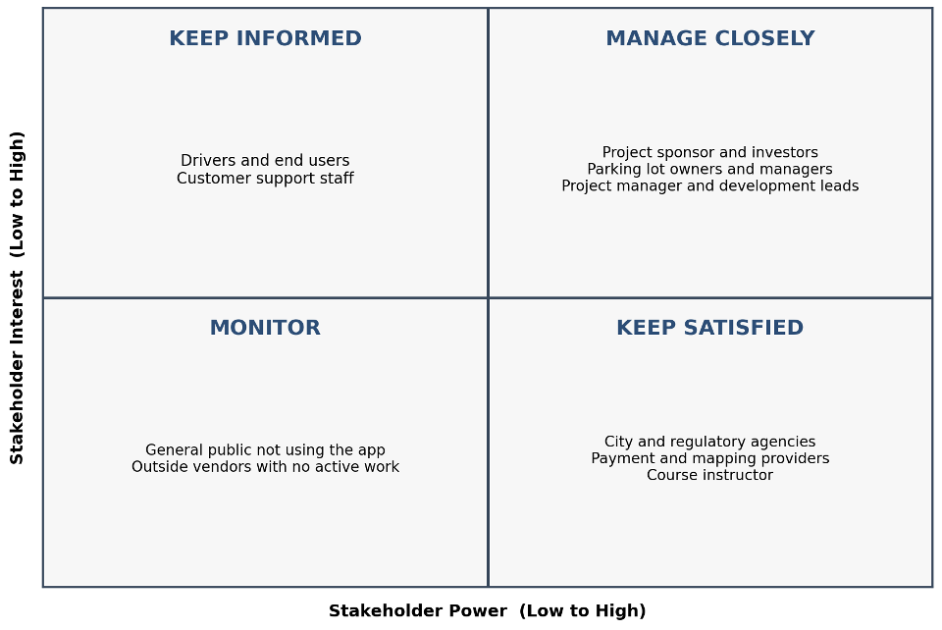
Manage closely: The project sponsor, parking owners, investors, managers and the development leads also. They’ll receive progress updates, budgets, and risks.
Keep Satisfied: City and regulatory agencies payment and mapping providers, and the course instructor. Contact them for approvals,issues, major changes, and milestones.
Keep Informed: Drivers, end users, and customer support staff. Give them feature updates, surveys, testing opportunities and release information.
Monitor: The general public who doesn’t use the app and outside vendors with no active work. They only need general information unless their power or interest changes and they want the app or website and to be a part of it also.

Smart Parking Platform Team Charter
Team Mission: Plan and develop a reliable website and mobile application that helps drivers find and reserve, and pay for parking while helping parking operators manage their locations.
Team Scope: The team will work on the website, mobile apps, backend database, live parking map, reservations, payments, notifications, reporting, security, testing, deployment, and operator training.
Main Goals: Complete the planned features within the 12 month schedule, and keep the project within the approved budget, protect user and payment information, and make the platform easy for drivers and parking operators to use.
Team Members: Carter Will is the project manager. Aashi Patel handles UI and UX. Jordan Cooper develops the website. Priya Shah develops the mobile apps. James Brooks develops the backend and APIs. Sofia Martin works on maps and parking management. Lucas Green works on payments. Chloe Chen handles testing. Ethan Wilson handles DevOps. Grace Smith handles security. Davis Lee is the parking operator so he will collect information and feedback from the garage management.
Roles and Responsibilities: Each person is responsible for the work assigned to their role. The project manager tracks the schedule, cost, risks, decisions, and communication. Technical leads report issue early and work with QA before work is considered complete.
Team Values: The team will be honest about project status, respect each persons work, protect customer information, document important decisions, and focus on creating a dependable system.
Working Rules: Team members will update trello when a task changes, attend scheduled meetings, review work before merging it, report blockers quickly, and avoid making major changes without discussing them with the affected teams.
Communication: The development team will have short daily meetings. Team leads and the project manager will meet weekly. Trello will track tasks, shared documents will store requirements and decisions, and urgent problems will be reported directly to the Project Manager.
Decision Making: The team will discuss technical decisions with the people doing the work. The project manager will make the final decision when the team cant agree or when the decision affects the schedule, budget, or scope.
Conflict Resolution: The people involved will first discuss the issue directly. If it is not resolved, the Project Manager will review the facts, project requirements, schedule, and risks, then choose the option that best supports the project.
Measures of Success: Tasks are completed on schedule, major features pass testing, major security problems are resolved, costs stay within the approved budget, and drivers and parking operators can complete their main tasks without confusion.

Smart Parking Platform Project Charter
Project Title: Smart Parking Platform
Project Manager: Carter Will
Project Purpose: Parking can be difficult because drivers may not know which spaces are open, whether their vehicle fits, how much parking costs, or where to pay. Parking operators also need a better way to view how full the garage is, reservations, payments, and reports.
Project Goal: Create one website and mobile platform where drivers can find available parking, reserve a space, pay securely, receive directions and alerts, and view receipts. Parking operators will have a separate dashboard for managing spaces, rates, users, and reports.
Main Objectives: Create secure driver and operator accounts, show parking availability on a live map, support reservations and payments, send confirmations and alerts, provide reports, and complete testing before the final release.
In Scope: Website, iOS and Android apps, user and operator accounts, live maps, parking space information, reservations, payments, receipts, notifications, reporting, security, cloud deployment, monitoring, and training.
Out of Scope: Buying or constructing parking garages, manufacturing parking sensors, enforcing parking laws, towing vehicles, and maintaining roads or physical parking equipment.
Main Deliverables: Approved requirements, website, mobile apps, backend database, parking map, reservation system, payment connection, operator dashboard, reports, tested release, training information, and project documentation.
Schedule: The project will use a 12 month plan. Early months cover requirements and design, the middle months cover development and imbedding, and the final months cover testing, training, deployment, and support.
Estimated Budget: $1,188,295, including labor, other project costs, and a 15 percent contingency reserve.
Main Stakeholders: Drivers, parking lot owners and managers, project sponsor and investors, development team, payment and mapping providers, regulatory agencies, customer support staff, and the course instructor.
Main Risks: Incorrect parking availability, double booking, payment or mapping outages, exposed user data, delayed vendor approvals, higher cloud or API costs, schedule delays, and disagreements about requirements.
Project Success: Drivers can search, reserve, pay, receive directions, and view receipts. Operators can manage spaces and view reports. The system passes security and reliability testing, meets the main requirements, stays within the budget, and is completed within the planned schedule.
Project Manager Authority: The project manager can assign project work, schedule meetings, approve normal task changes, track the budget, escalate major risks, and request decisions from the sponsor when a change affects the approved scope, schedule, or budget.

